## WebDev Quiz 2

**Note: Task 1 has to be done by everyone. You have an option between task 2 and 3**

**Task 1:**

Make form for API: Auth/login

Make table for API: Profile/UserProfile (youcan use <https://mui.com/material-ui/react-table/#basic-table> – not necessary)

**Task 2:**

Display FAQ questions list using API: Content Related/Get Faq

**Task 3:**

Create form using data from: Quiz/Common Quiz Dynamic

Send that data in API: Quiz/Post Quiz

**How to POST FormData:**

Instead of:

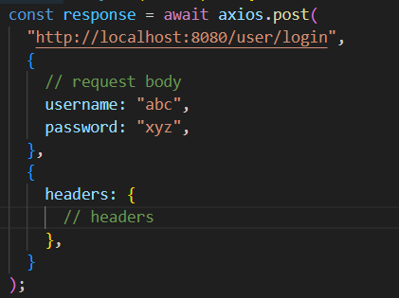

Do:

